Experiment No: 2

Experiment Name: Host Discovery

Aim
To discover active hosts in a network using Nmap host discovery techniques.

Procedure
- Open Kali Linux and launch the Terminal.
- Check the Nmap installation:
- Identify the authorized network range to be scanned.
- Perform host discovery using the -sn option:
- Nmap sends host discovery probes to identify which devices are active.
- Observe the IP addresses of the hosts that are reported as Host is up.
- Record the discovered active hosts.
output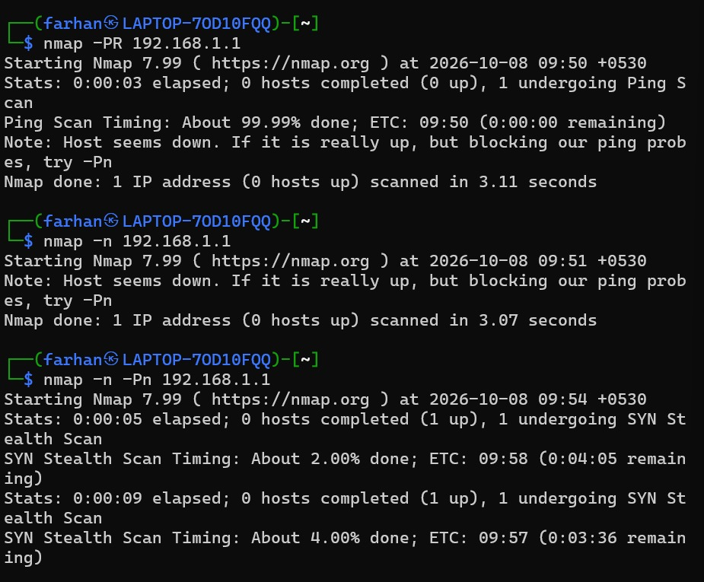
- 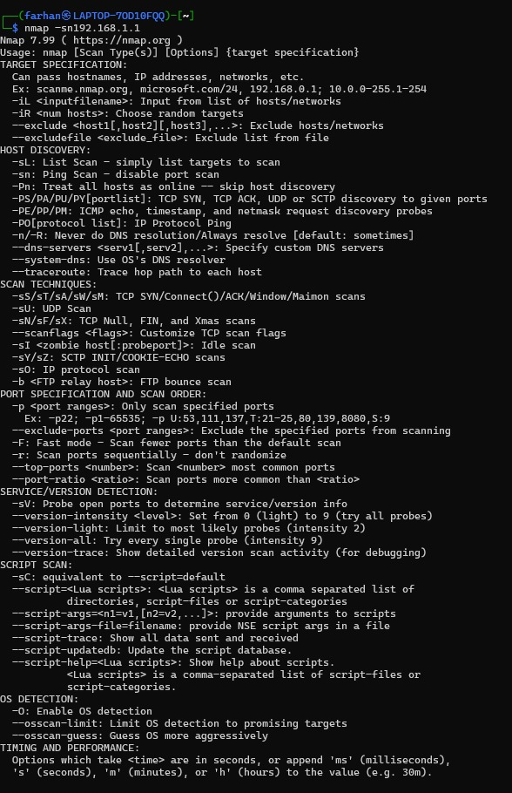

Result
Thus, host discovery was successfully performed using Nmap, and the active hosts in the authorized network were identified.

